Lab 4 Worksheet Sedimentary Rocks
Name ______ (-2 points if missing)
Date _______
Use your textbook, lab and lecture PowerPoints, and internet as needed to answer all questions in each of the 2 parts. Please explain everything in your own words.
Part 1
Rock name | Description of your personal sample: Include texture (as described in the ppt), composition, and any identifiable minerals, or explain why there are no identifiable minerals.
- Shale
- Calcareous Tufa
- Sandstone
- Conglomerate
- Limestone

Part 2
- How could you determine which cement is holding your sandstone together?

- Shale comes in many different colors. What color is your sample?

- Based on the description of limestones in the lab ppt, what type of limestone is shown here?
  - 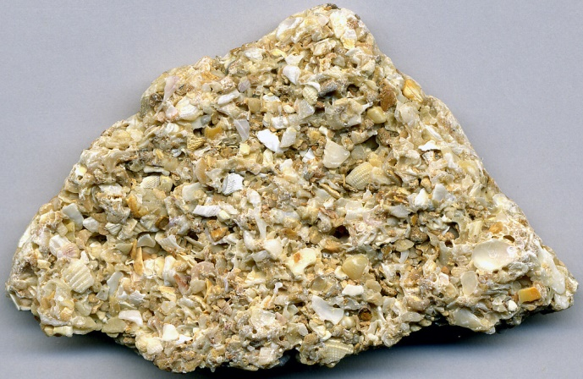

- Identify a test to quickly determine any kind of limestone.

- Explain how the clastic rocks tell us about the distance from the sources of the grains.

- What is the difference between travertine and micrite?

- Identify at least 2 depositional environments for shale.

- Where is a place near you in which future sandstone may be in the process of forming?

- Explain the difference between grain rounding and sphericity.

- Classify the following sedimentary rocks as either clastic, chemical, or biogenic.
Gypsum
Coal
Breccia
Rock salt
Coquina
Sandstone

- Identify a place on earth where rock salt is forming right now.

- Would a conglomerate be well sorted or poorly sorted, and why?

- What type of rock is pictured here?
  - 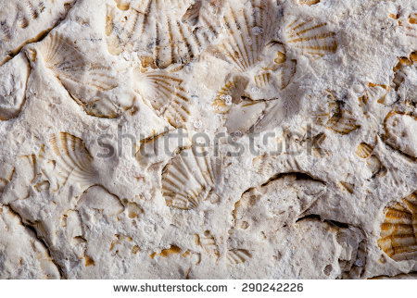

- Describe the rock in the image in terms of rounding and sorting
  - 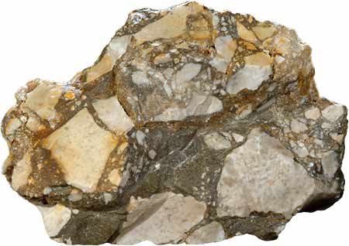

- What future rock would be developing in a V-shaped mountain valley?

